

The British College
Kathmandu
Coursework submission coversheet
(individual coursework only)
LBU Student Id:
For Checking by the student:
77466864
Please ensure all information is complete and correct and attach this form securely to the front of your work before posting it in a coursework collection box.

Award name: BSc (Hons) Computing
Module code: 14806 – LTP - 202510
Module name: COMP607 -Production project
Module run:
Coursework title: Comparative Evaluation of Vision-Based Finger Tracking for Piano Interaction
Due Date: 5th May 2026
Module leader: Patrick Ingham
Module Supervisor: Mr. Saroj Sharma
TURNITIN checked: YES NO (please circle)
Submission date & time: Date: Time:

Total Word Count: Total Number of Pages (including this front sheet):

In submitting this form with your assignment, you make the following declaration: I declare, that the coursework submitted is my own work and has not (either in whole or part) been submitted towards the award of any other qualification either at LBU or elsewhere. I have fully attributed/referenced all sources of information used during the completion of my assignment, and I am aware that failure to do so constitutes an assessment offence.

Signed: Date:
You are strongly advised to retain a second copy of your work in case of any query about the assignment.
For completion by the faculty:
Teacher's Signature: _____________________________ Date: _________________________
Production Project
Comparative Evaluation of Vision Based Finger Tracking for Piano Interaction

Acknowledgement
I would like to thank my supervisor Sir Saroj Sharma and my module leader Dr Rohit Raj Pandey for providing me with feedback and academic guidance provided throughout the lifecycle of this research. The regular meetings and feedback from supervisors have been invaluable experience and helped in especially refining the methodology and acting according to project schedule. I would also extend my gratitude to the participants who were willing to volunteer in dataset collection stepping into an unfamiliar domain of musical instrument and artificial intelligence.

Abstract

Student Declaration
I, Aayam Regmi (Student ID: 77466864), declare that this report is my own original work submitted with fulfilled requirements, ethical consent of Leeds Beckett University for the production project of BSc (Hons) Computing and The British College. All cited references are in accordance with Harvard referencing format.

Table of Contents
Acknowledgement 3
Abstract 4
Student Declaration 5
Table of Contents 6
List of Resources 8
list of figure tables or graph 8
list of appendices 8
list of Abbreviations 8
1. Introduction – 500 words 9
2. Review of literature 10
3. Review of technology – 800 words 12
3.1 Major Hardware Components 12
3.2 Software Components and Libraries 15
4. Methodology 500 words 16
4.1 Methodology description 16
4.2 Research design plan 16
4.3 Methodology defense 17
5. Research/ Product design 17
5.1. Data collection pipeline system 18
6. Implementation and Testing 19
6.1 Dataset Collection Pipeline Overview 19
6.2 Participant and Environmental Characterization 19
6.2.1 Skin Tone Classification (Fitzpatrick Scale) 19
6.2.2 Ambient Illuminance Classification 20
6.2.3 Hand Size Classification 21
6.3 Pipeline MJMPE Calibration and Bias Reduction 21
6.3.1 Horizontal MJMPE: Fingertip-to-Key Centre Offset 22
6.3.2 Polygon Containment for Finger Detection 22
6.3.3 Perspective Homography Calibration 24
6.4 Synchronized Multi-modal Data Acquisition 26
6.4.1 MIDI–Video Temporal Alignment 27
6.5 System Performance and Detection Statistics 27
6.6 Participant Study Design 28
6.6.1 Participant Recruitment and Inclusion Criteria 29
6.6.2 Session Protocol and Procedure 29
6.6.3 Dataset Structure and Storage 29
6.7 Offline MJMPE Analysis 29
7 Results 30
7.1 Overall Model Performance 30
7.2 Per-Hand Accuracy 30
7.3 Per-Finger Accuracy 30
7.4 Effect of Skin Tone (Fitzpatrick Type) 30
7.5 Effect of Ambient Illuminance 30
7.6 Effect of Hand Size 30
8. Conclusion 31
9. Installation guideline 31
10. Bibliography 31
11. Appendices 33

List of Resources

list of figure tables or graph

list of appendices

list of Abbreviations
API – Application Programming Interface
BGR – Blue, Green, Red
CIELab – Commission Internationale de l'Éclairage (Lab colour space)
CLI – Command-Line Interface
CNN – Convolutional Neural Network
CSV – Comma-Separated Values
CV – Computer Vision
DR – Detection Rate
FPS – Frames Per Second
GPU – Graphics Processing Unit
GUI – Graphical User Interface
HCI – Human-Computer Interaction
ITA – Individual Typology Angle
JSON – JavaScript Object Notation
MIDI – Musical Instrument Digital Interface
MJMPE – Mean Joint Model Positional Error
MoSCoW – Must, Should, Could, Won't (prioritisation method)
MPJPE – Mean Per-Joint Position Error
PAF – Part Affinity Field
RAD – Rapid Application Development
RGB – Red, Green, Blue
ROI – Region of Interest

Introduction – 500 words
This research aims to evaluate various metrics of widely used vision-based hand tracking models. MediaPipe hands and OpenPose are some frameworks that will be mainly focused on. The ground truth to evaluate the metrics will be an electric piano (CTK-2400). The captured MIDI data synchronized with video footage timestamps will ensure a fair comparison between both models. An overhead camera will display finger landmarks and the position of these landmarks. When a MIDI signal is detected, calculation of the distance between the played key and the landmarks will be computed. According to a certain threshold value, the calculation will be deemed accurate or false flags. The research also aims to show if any correlations exist between hand tracking models, lighting conditions, hand size and skin tone diversity. Skin tone diversity is considered as a metric here to evaluate if there is any disparity between diverse groups in context of hand tracking. Buolamwini and Gebru (2018) assessed vision systems in context of various skin tone groups across various skin tone groups demonstrating accuracy disparities. This became an evaluation variable for fixing diversity biasness. Mehrabi et al. (2021) described dataset homogeneity while training a model is a primary source of bias. The results would provide clear proposals for potential improvements on computer vision models back by controlled data collection methods and give recommendations for training music-related models.
‘Comparative Evaluation of Vision-Based Finger Tracking for Piano Interaction’ combines several fields of applied computing. From real time pose estimations, visual landmarks, temporal tracking and HCI are some blends of this topic. Algorithm fairness is also a big discussion as training a vision model requires a fair dataset with fairness to all groups of people. The piano was selected as ground truth for this research due to its unique design and finger tracking potential. Playing a piano piece can be rigorous for hand tracking models in case of going from slow to fast rhythm and finger overlaps. The piano design shows closely packed keys which could produce localization errors as well as temporal smoothness issues. These factors need to be considered when using a single camera vision tracking models which rely on frame RGB analyzation. There are three main variables mentioned before to be considered while stress testing vision models. The first variable is testing multiple levels of illuminance. The SI unit of illuminance is lux, which measures the amount of visible light on the surface. The second variable is participants hand size, from one end to the other of the palm measured manually. This variable was considered to test any localization errors between various hand sizes. The third variable is skin tone for algorithmic fairness. The Fitzpatrick scale (Fitzpatrick, 1988) will be used to categorize participants’ skin tone data for later analysis. The Fitzpatrick scale was developed and published in 1988 which classifies skin pigmentation and reaction to UV light under 6 types (I-VI). Cho et al. (2023) stated that the Fitzpatrick phototype provides a fair scale for evaluations rather than subjective labelling.

Paragraph 3 complete at last summarize each chapter

Review of literature
The Xbox 360’s Kinect developed by Microsoft was one of the earliest consumer grade hardware finger tracking systems. It featured pose estimations for video games as well. The main restriction the Kinect posed was requiring depth sensing hardware, imposing a three-dimensional constraint. The fine-tuned conditions required for tuning such hardware meant an embedded system developer had to consider increment in hardware cost and code complexity. Han et al. (2013) reviewed the Kinect in hand gesture analysis and achieved great performance while considering the hardware constraints and complexity imposed by the device. Modern frameworks utilizing deep learning based, RGB camera tracking systems have drastically changed to landscape of vision systems. Training convolutional neural networks (CNN) for classification jobs is the go-to method for vision systems today. Well annotated hand images, diverse lighting conditions and skin tone diversity meant highly accurate tracking results. With even a single camera system joint localization is possible with real time. Experiments with low hardware cost are now possible in jobs such as vehicle number plate analysis, VR and HCI systems.
A standardized approach for hand anatomy was introduced due to the transition from depth-based systems to single camera real time RGB landmark detection system. The approach followed by most landmark-based models is outputting a fixed skeleton of joint coordinates per frame, rather than processing all the pixels for each frame. This provides a lightweight and consistent downstream system with structured positional data. Molchanov et al. (2016) demonstrated that such a landmark identification system can achieve reliable classification without specialized depth sensor hardware. The ability to run such models on standard consumer-grade hardware like a CPU meant an expanded usability. This accessibility lowered a barrier for developers to build certain applications like sign language recognition tools, gesture-based interfaces, and HCI systems. An everyday tutor and feedback system based on musical instruments is a strong candidate for research using the most relevant models to evaluate their suitability in rapid finger movement musical performances. Mueller et al. (2018) demonstrated joint coordinate RGB based system and approach accuracy like systems with depth sensor hardware in controlled environments.
MediaPipe Hands, developed by Zhang et al. (2020) at Google Research, is the most relevant open-source model for this research. The principle that this framework works on is identifying palm borders by hand bounding boxes. The landmark model features 21 three-dimensional coordinates, with a detected bounding region. These landmarks translate into biological parts and joints of the human hand, including the fingertip. MediaPipe Hands is notable for being a lightweight model. Performance of 30 frames per second on a CPU alone is showcased by this model. This makes this framework suitable for real-time vision-related tasks. However, a common reported problem from the open-source community is that occlusion poses a significant performance loss. In the case of the piano, occlusion occurs when fingers overlap in a music performance, making it a common performance loss factor.
The OpenPose framework represents a different approach for finger tracking. Developed by Cao et al. (2019) at Carnegie Mellon University, it uses two-dimensional vector fields to encode joint direction and relation across the image, establishing spatial relationships. This approach can detect and associate multiple human features, including hand key points, simultaneously through the network via a single forward pass. Jo and Kim (2022) concluded on their comprehensive study benchmarking OpenPose, PoseNet, and Movenet concluded at the cost of computing power OpenPose achieved higher accuracy than other lighter models in multi-person scenarios. Chung et al. (2022) studied and concluded at the price of time and performance heavier architecture consistently outperformed light models in terms of accuracy. Notable limitation of OpenPose is performance on CPU hardware falling below 15-20 FPS, and a lack of temporal smoothing features. In a piano setting the lack of temporal smoothing might cause keypress false flags, which directly entail accuracy reduction.
In the context of music, finger tracking systems have been explored in the instrument learning context. Liang et al. (2016) developed a virtual piano system with real-time hand interaction controls using an RGB-D camera. The fingertip tracking keypress features inverse kinematics and finger trajectory predictions. The system showed over 90% accuracy on finger press detection. A drawback is the virtual piano required specialized depth-sensing hardware in addition to the standard RGB input. This setup couldn’t be further refined to a more consumer-friendly setup due to this. Hiranaka Grown-Haeberli and Xue (2022) later used MediaPipe hands in the same domain of an augmented reality piano application for a purely RGB-based system. The augmented reality system achieved 81% accuracy at 12 frames per second. An improvement was this system was designed on commodity hardware. A few major disruptions in tracking failures and accuracy degradation were observed on finger overlapping moments. Salz and Azam’s (2019) virtual piano study had incorrect note assignments even from small positional errors. This highlighted the requirement of precision threshold for such systems. These studies confirmed the limitations of single-viewpoint tracking systems, which are not captured by controlled dataset benchmarks.
For real time feedback pose estimation system, temporal smoothing techniques have been applied to reduce landmark jitters. A study done by Lugaresi et al. (2019) used the MediaPipe framework to reduce computing power by not using traditional frame by frame approach. The study used landmark calculations via prior frames meaning only the algorithm was lightweight. This was especially better for high motion situations requiring coordinate stabilization. One drawback was in cases of very unexpected prior frames with rapid movement; unexpected delays were observed. Moments where the piano key was unpressed, redetection added measurable latency, causing inaccuracy in model prediction. Research on adaptive detection using prior frames could be explored rather than relying solely on per-frame identification to address rapid finger transitions.
The architectures handling hand tracking using a single camera faces problems with occlusion. For research purposes Hürst and Van Wezel (2013) designed a system that works with gesture-based models. They concluded that self-occlusion and finger overlaps caused the most misclassification. Multiple testers reported experiencing confusion, and accuracy drops during events with finger overlaps. Recent architectures utilizing MobileNet backbone, have tried discarding landmarks below a certain threshold to combat false positives. This approach introduced tracking gaps while eliminating false positives in occlusion events. Pu et al. (2023) assessed HPE model’s robustness under occlusion and rapid motion, revealing real world events reduce landmark detection more than what controlled experiments show. Methods for interpolation or prediction of these gaps could be further expanded upon for piano performances where fast music pieces with a lot of finger overlaps are main occlusion sources. Some improvements like implementing a predictive interpolation algorithm for handling occlusion could certainly improve tracking rate for most musical pieces and applications.

Review of technology – 800 words
To conduct and produce meaningful research results, a combination of hardware and software has been picked precisely per requirement. The following sections below are some of the hardware devices used

3.1 Major Hardware Components
- Casio CTK-2400 electronic keyboard: this electrical piano provides a USB connection to any host machine using a printer cable. This allows MIDI signals to be read using python library Mido, which can be used to sync timings and MJMPE calculations. With the 61 keys, enough length for two-handed capture is possible.
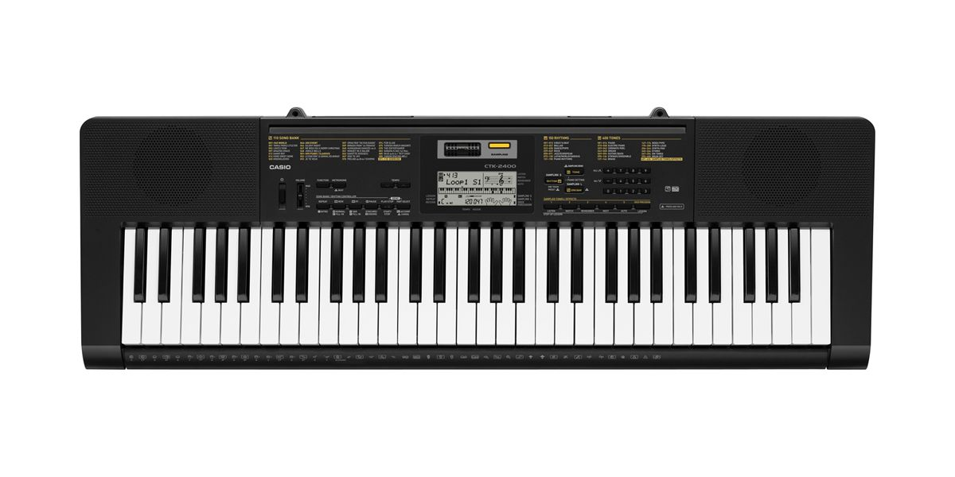
Fig: CTK-2400 electrical piano
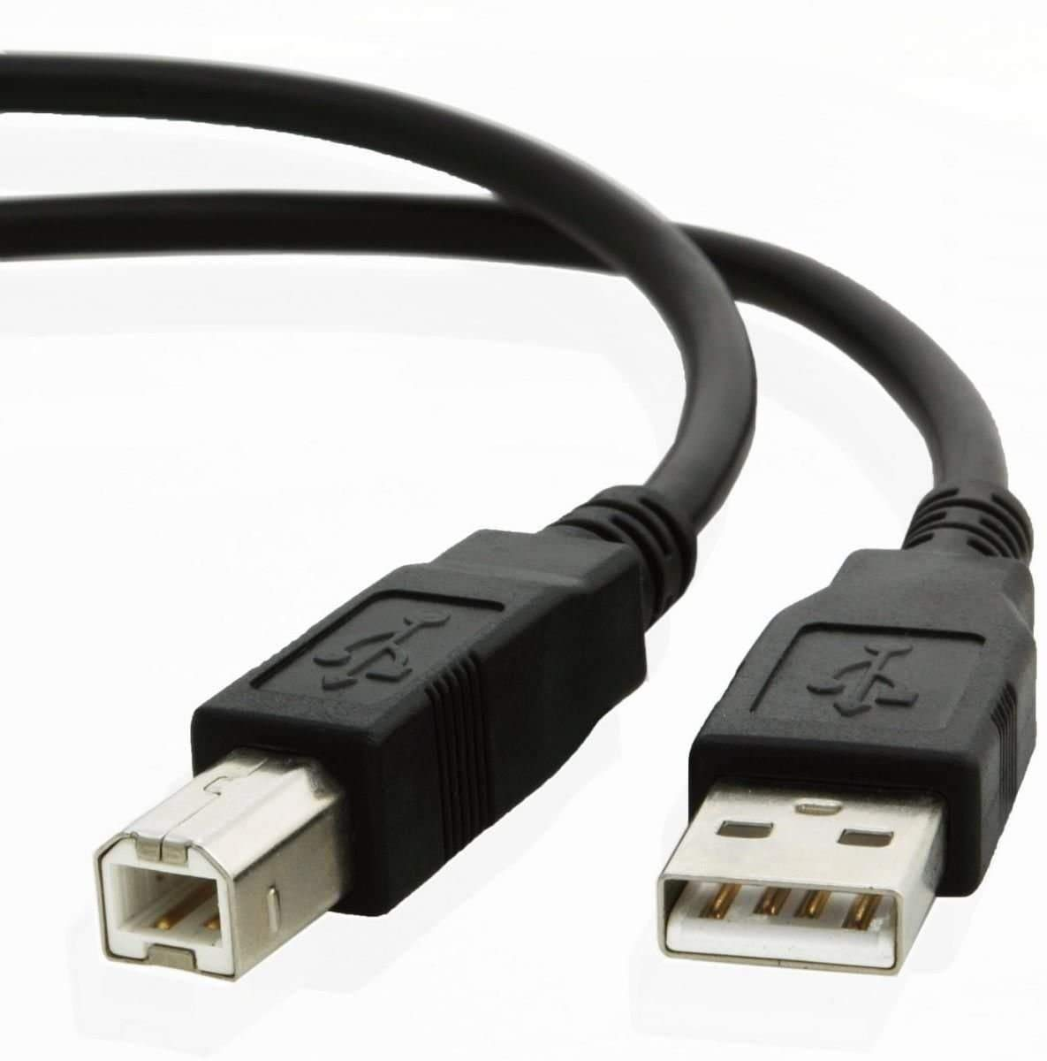
Fig: USB 2.0 to USB 3.0 cable

- Mobile camera connection through USB Type-C: The Google Pixel 7 was used via webcam option from the USB debug setting. The smartphone sensors can also be used to determine the illuminance of the environment.
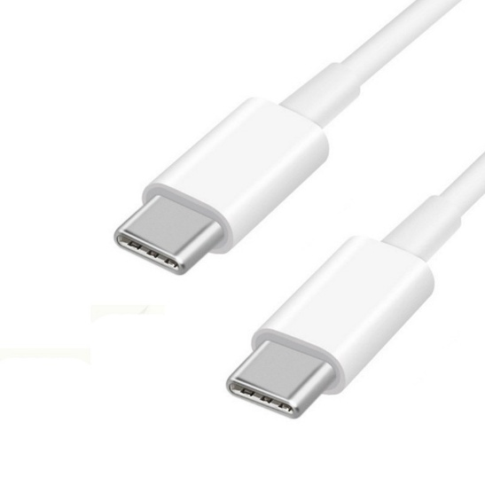
Fig: Google Pixel 7 and USB Type-C cable

- Adjustable Camera Tripod: A camera tripod with a mobile phone adapter mount can ensure fixed recording height and angle, reducing any bias in data processing later.

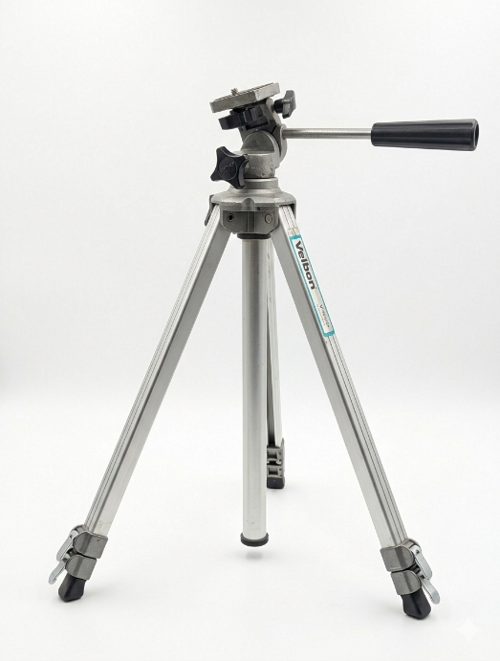
Fig: Velbon adjustable camera tripod

- Host machine: The laptop used for developing the system and data processing is a Msi gaming laptop with Intel i-7 14th gen process with NVidia RTX 5070 mobile chip with 16gb RAM. This hardware enables fast data processing and model execution even in live video preview with the help of Nvidia CUDA support in Python libraries.
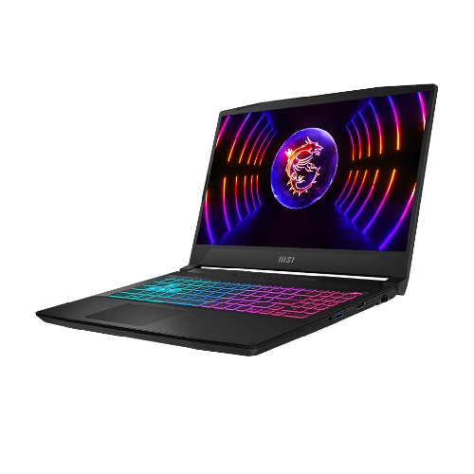
Fig: MSI gaming laptop

3.2 Software Components and Libraries
- Python 3.10+: The previous version of Python is used here due to the libraries not updated to work with the latest Python releases as of March 2026. Python 3.10 enables support for OpenCV and MediaPipe, making it the better choice for using a virtual environment. With support for machine learning libraries, good documentation, and CUDA performance, Python is chosen.
- NumPy: A Python library that can process thousands of data in a structured format efficiently, in the case of this research, the midi timings and midi signals along with MJMPE calculations
- Pandas: A Python library where data can be put into a certain structure for easy retrieval and storage
- OpenCV: The cv2 Video capture allows retrieval of frames through USB connectivity and allows distortion fixes for individual frames. This is especially important as OpenCV also provides metrics to frames per second and latency to avoid a <20fps risk
- Mido and python-rtmidi 1.5.0: Mido is an opensource python library that provides low-latency MIDI signal capture using a high-level language.
- Matplotlib: Visualization of final data using graphs to show the impact of various variables considered while collecting data
- Git: Enable safe work version control in case a revert is required
- MediaPipe Hands: Actual testing framework for hand detection.
- OpenPose Hands: Second testing framework for hand detection.

Methodology 500 words

4.1 Methodology description
Rapid Application Development (RAD) methodology was chosen for the development of the data collection system for this research. Martin (1991) defined the RAD as the development of rapid, time-boxed cycles of requirements analysis, prototype construction, user feedback, and revision. A fully completed specification is not required upfront, and RAD prioritizes development by understanding the requirements and system and testing fundamental functional requirements first.

4.2 Research design plan
The Gantt chart starts with the initiation and risk planning of the research in December and ends with the research presentation in the month of May, totaling a time of twenty weeks. After allocating the time for hardware testing and software setup, the main data collection system development starts. The project timeline and the Gantt chart display Phase 2 (Weeks 5–8), the rapid development of hardware sync, data collection pipeline, and real-time overlay system creation over the span of four weeks. Since the hardest part of the research is to collect enough data to produce meaningful results, the main data collection phase, Phase 3 (Weeks 9–12), has been prioritized to be done in the span of about three weeks. This phase is to collect data following the ethical considerations posed by the university and signed contracts, which introduce user identity safety. In Phase 4 (Weeks 13-16), the analysis phase compares MJMPE, secondary metrics, and overall statistics along with result visualization using graphs. Phase 5: producing a meaningful report that spans from the beginning to the end of the research, tabulates result variables, and outputs research-backed feedback for vision-based models and produces a new dataset governing vision and music instrument interaction contribution for the open-source community, and ends with a conclusion that can be further explored via other research and projects.
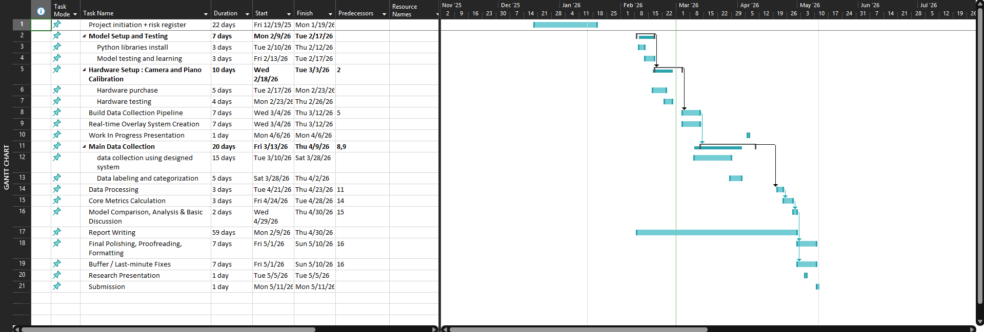
Fig: project timeline and Gantt chart

4.3 Methodology defense
Several methodologies were proposed at the beginning of the project initiation. Before RAD was considered, the waterfall methodology was reviewed. The waterfall methodology expects a linear approach and allows no time for iterative refinement, recursion, and reverting in case of system failure. The research expects several experiment protocols to be fulfilled, including playing specific patterns, computation of MJMPE and failure detection, vision models, landmark estimation, and adjustment pilot testing. Waterfall methodology would have introduced unnecessary overhead in case of these factors needing adjustment. The second methodology considered was Agile, which is highly suitable for team-based software development projects. It introduces multiple terms and events that suit more of a product development cycle than a single-person research project. Agile was therefore rejected due to its emphasis on delivering user value in a sprint situation, which does not translate to statistical analysis and dataset tuning. RAD offers an optimal balance as it enforces completing functional development quota to display progress, while improving practical discoveries during the research lifetime. The flexibility provided by RAD methodology allowed valuable insight into MIDI timeline synchronization with video data timeline issues to be diagnosed and discussed.

Research/ Product design
General overview of the research
-100 words
-research system prototype example: dataset collection device
-functional and nonfunctional summary
-features, description and priority

5.1. Data collection pipeline system
Setting up the data collection pipeline from an upwards angle with almost a ninety-degree view is the initial setup for open-source models to track finger movement.
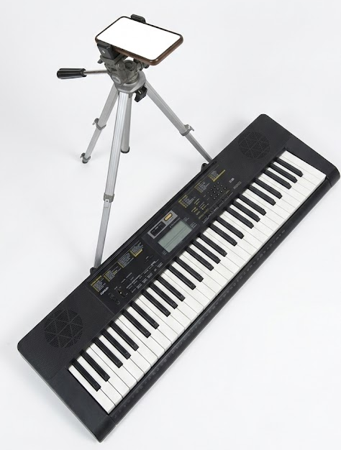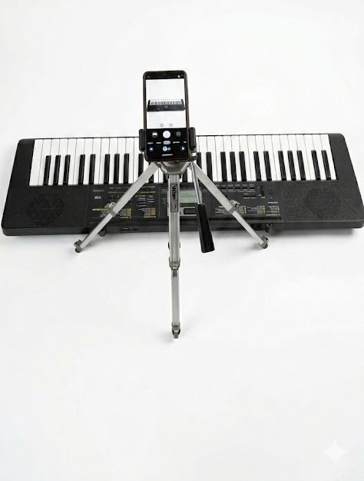
Fig: Data collection pipeline setup
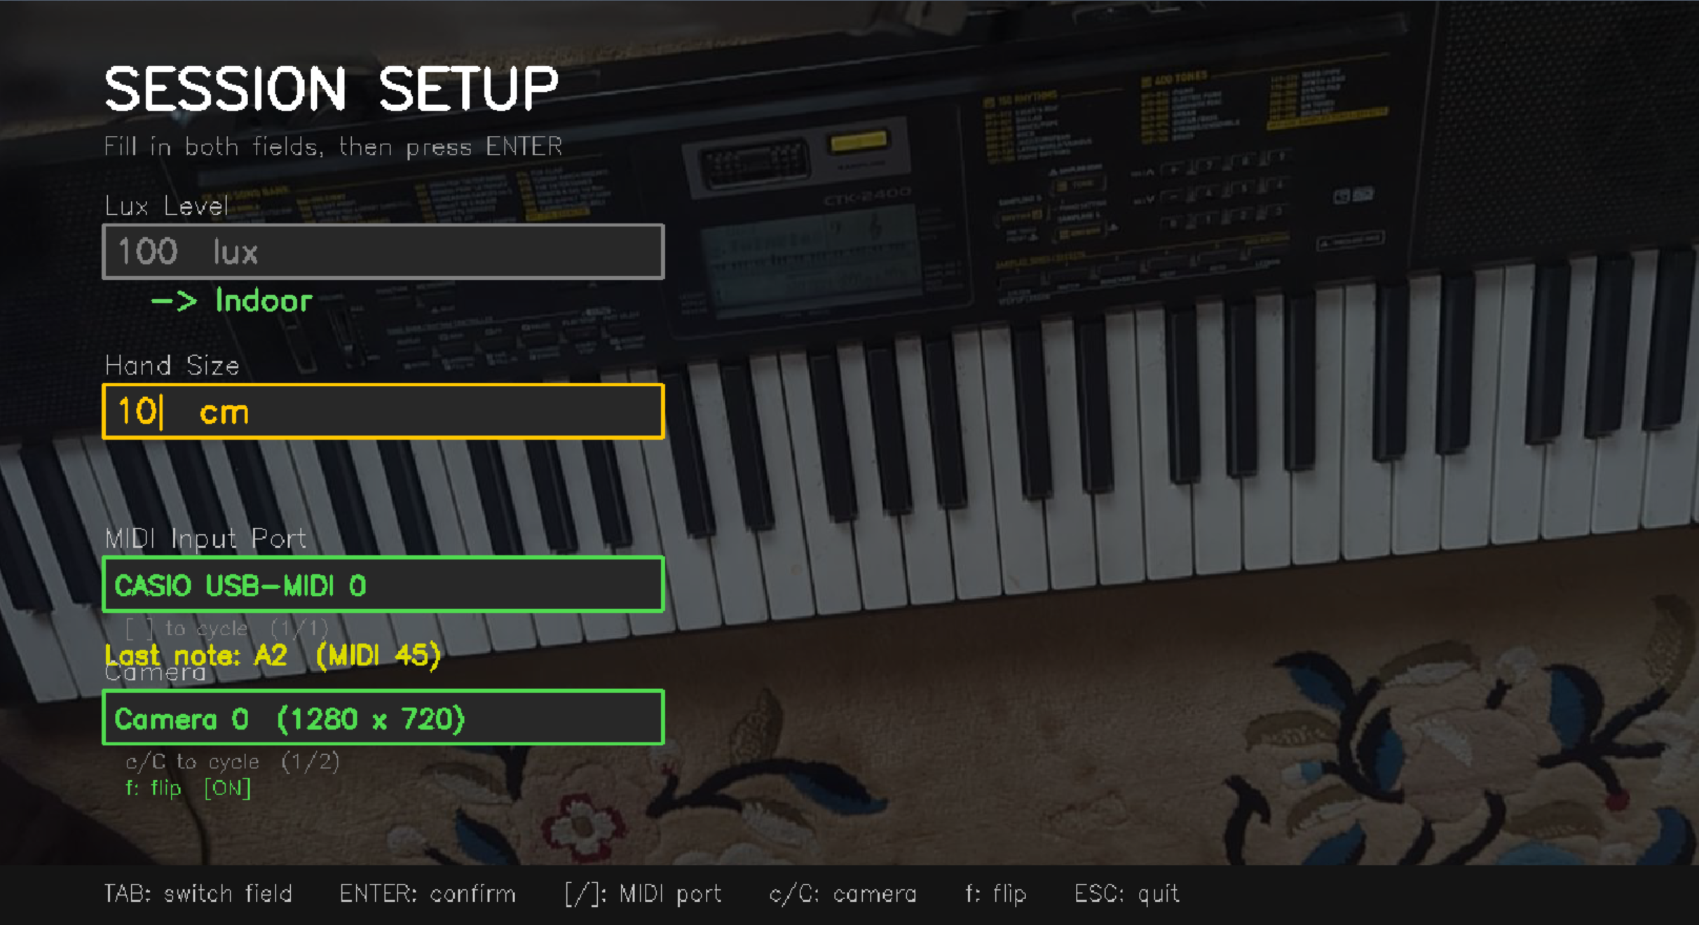
Fig: Session setup parameters

Implementation and Testing

6.1 Dataset Collection Pipeline Overview
The custom dataset collection pipeline has multiple features. The pipeline initialized a session where participants' data categorization is done automatically, an interface with a mask aligned to the piano keys marking the border and the center of the key to establish ground truth, midi streams, and video data are captured simultaneously for later offline MJMPE analysis. All participants’ data is saved under data/raw/p<id>, meaning no other personal details are stored, ensuring data confidentiality and anonymity.

Participant and Environmental Characterization
For cross-participant analysis, two variables were systematically logged before recording started. The first variable was skin tone categorization according to Fitzpatrick phototype. The second variable was ambient illumination measured by phones lux meter. The potential of both variables affecting landmark detection confidence in camera-based models was identified as a potential confound.

Skin Tone Classification (Fitzpatrick Scale)
The skin tone classification was done automatically using the colorimetric method (Chardon et al., 1991) using the individual typology angle (ITA). Without any external identification models, this method provides an independent skin reflectance measurement. CIELab pixel values from the palm region, which are MediaPipe landmarks 0,1,5,9,13 and 17, are sampled. The resulting ITA score is correlated with the corresponding Fitzpatrick scale category (Type I-VI). The resulting value is computed with 20 frames average.

The ITA score was computed as:
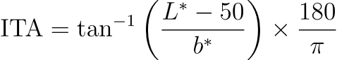
Where:
$L^{*}$: perceptual lightness
$b^{*}$: the yellow–blue opponent channel
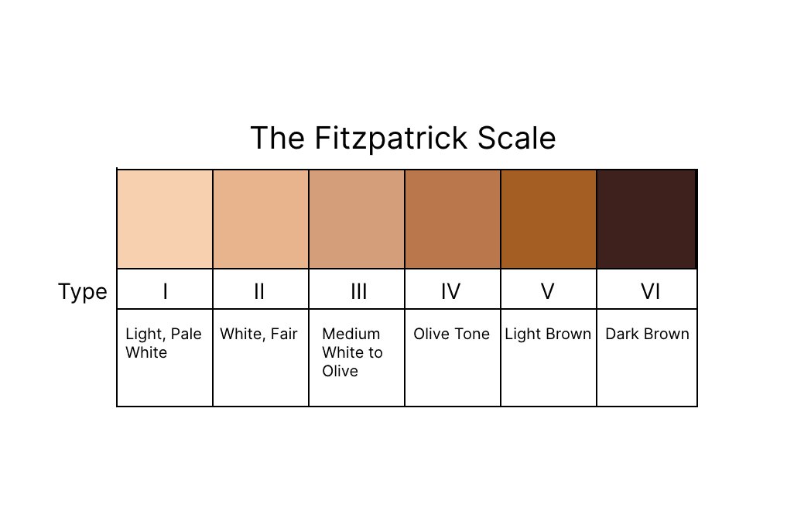
Fig: FitzPatrick scale (FitzPatrick, 1988)

Ambient Illuminance Classification
The Illuminance is classified by Dim (<100 lux), Indoor (100-499 lux), and Bright (≥ 500 lux). Rather than automatic measurement, manual entry was chosen over automatic measurement through a smartphone app displaying sensor data, to avoid dependence on additional hardware. This enables sufficient granularity for landmark detection performance under lighting variations. Lee et al. (2023) demonstrated significant accuracy loss under low illuminance for pose estimation models. In landmark detection landmark, light levels should be considered a primary variable to consider

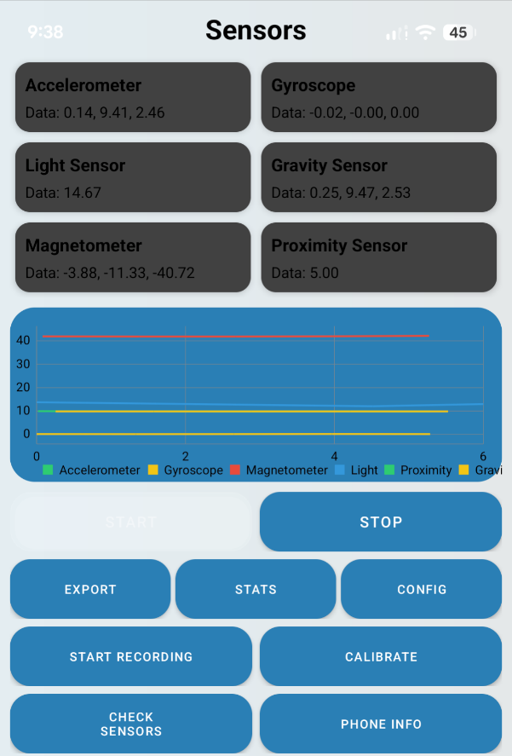

Fig: LUX Meter Mobile Phone (14.67 lux)

6.2.3 Hand Size Classification

6.3 Pipeline MJMPE Calibration and Bias Reduction
When developing the dataset collection pipeline, the 2D calculation of MJMPE introduced systematic bias due to the natural anatomy of human fingers. The fingers with the shorter distance were more towards the designed center mask of the piano overlay, causing bias to longer fingers playing the same or different key. The second metric that introduced bias was the piano keys being longer on the y-axis. When playing a selected note, if another finger besides the actual finger playing the note was nearer, a wrong flag was marked for artificially inflated MJMPE.
Results: <25% of the white key width (approximately 10px at the calibrated resolution) were classified as correct detection of landmarks

6.3.1 Horizontal MJMPE: Fingertip-to-Key Centre Offset
To address the first metric causing bias, the 2D MJMPE calculation was changed to horizontal-only displacement, removing the bias produced by natural finger depth.
Single-note horizontal error:
$$E\left(x\right)=|x_{tip}-x_{key}|$$
Where:
$x_{tip}$: predicted fingertip horizontal coordinate
$x_{key}$: horizontal center of the ground truth key
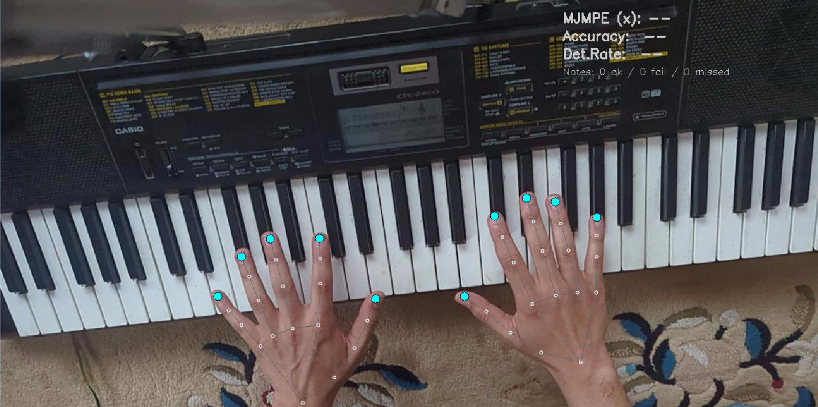
Fig: MediaPipe hands landmark preview

6.3.2 Polygon Containment for Finger Detection
The second metric causing biasness is the 2D centroid proximity finger to perspective polygon containment, meaning the fingertip lying within the physical bounding polygon is the note-playing finger. The solution is to implement a visual mask marking a key's boundary, which can be used to identify false flags as well.
When testing the initial system for dataset collection, a systematic misclassification was identified. Due to the configuration of polygon mask implementation half, the octave for left hand and half for right hand caused incorrect assignments of finger notes. This was improved upon by using MediaPipe’s native handedness output which gives left and right as output using landmark geometry (Zhang et al., 2020). This made the system model driven rather than screen position dependent
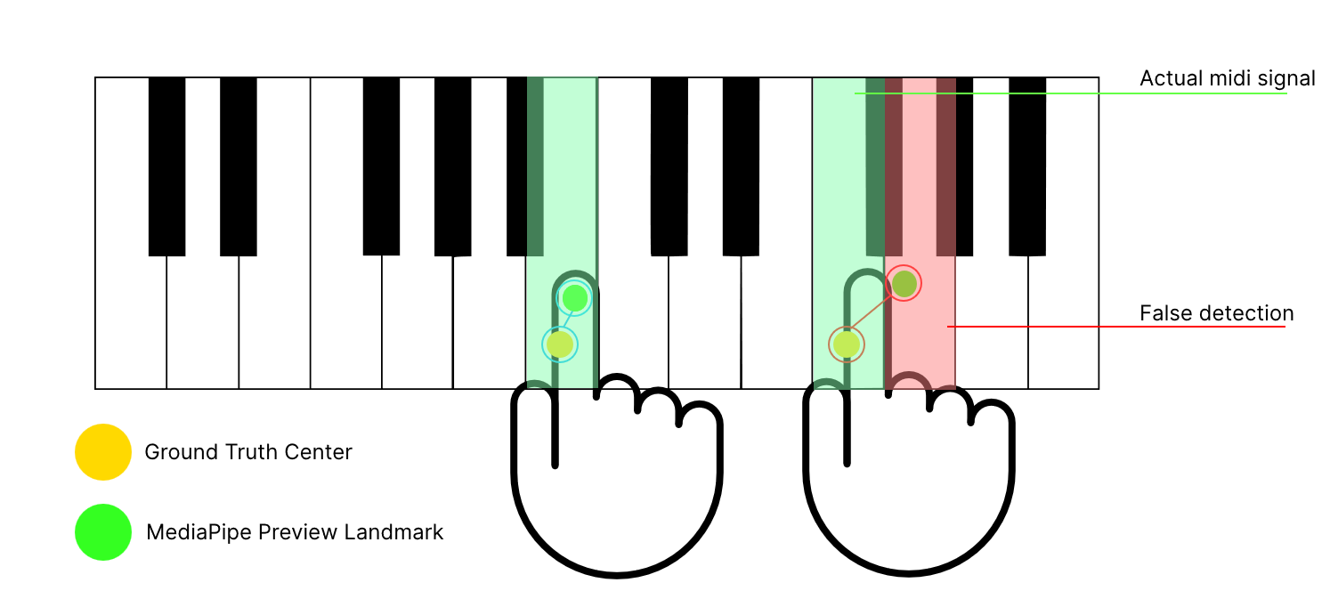
Fig: polygon containment mask
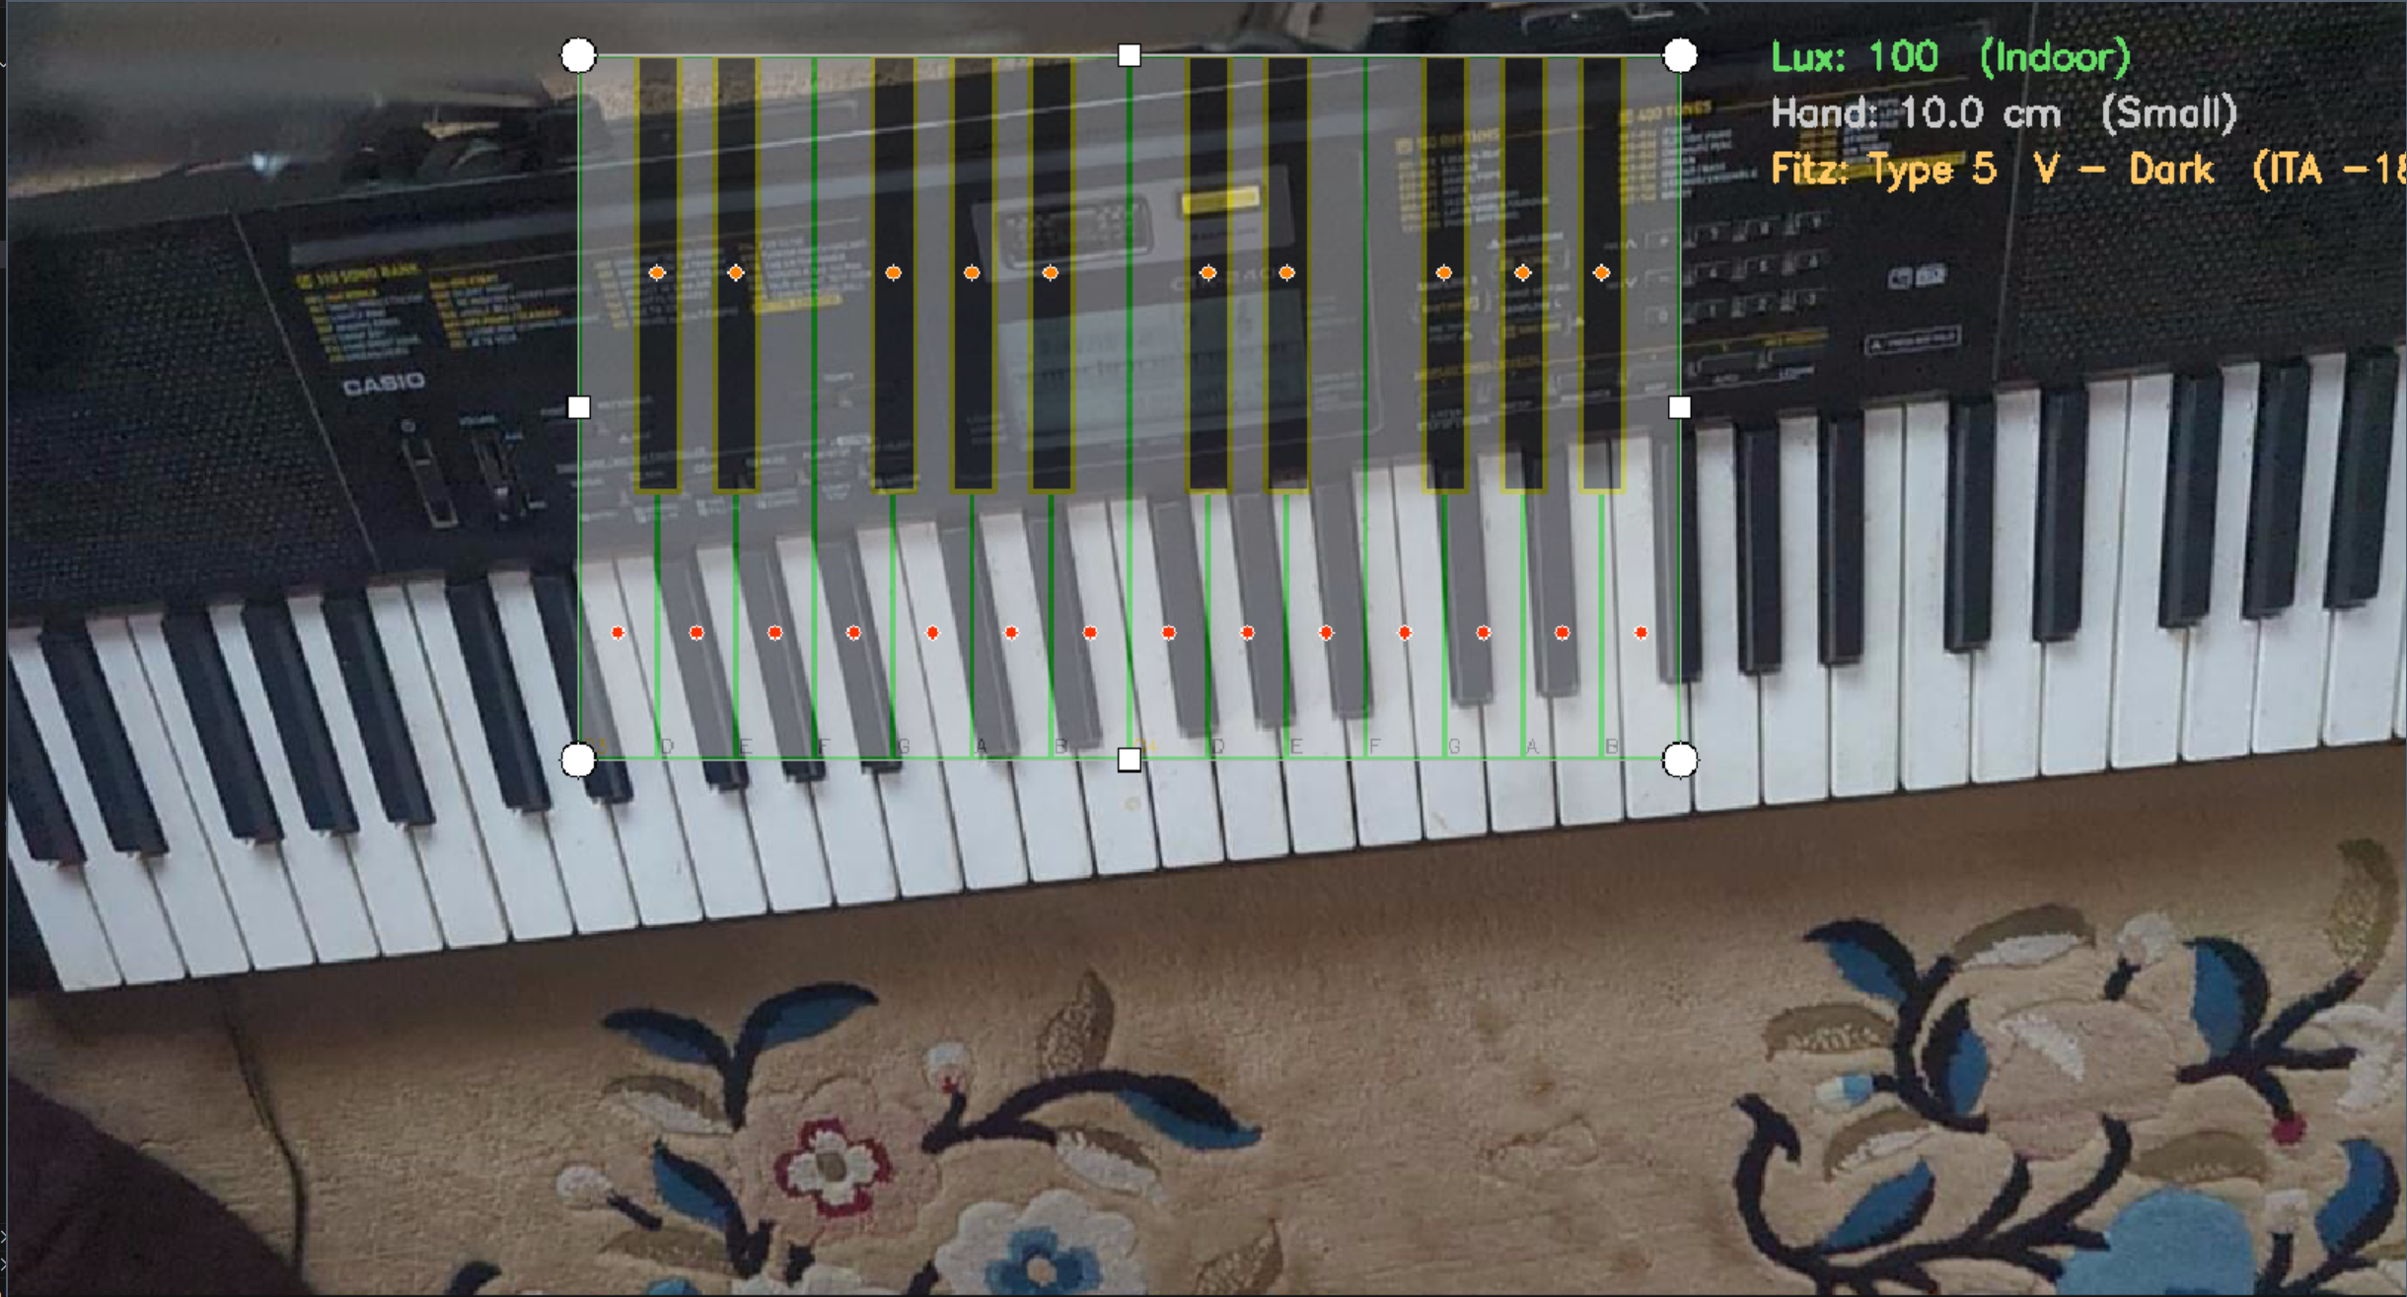
Fig: polygon containment mask preview
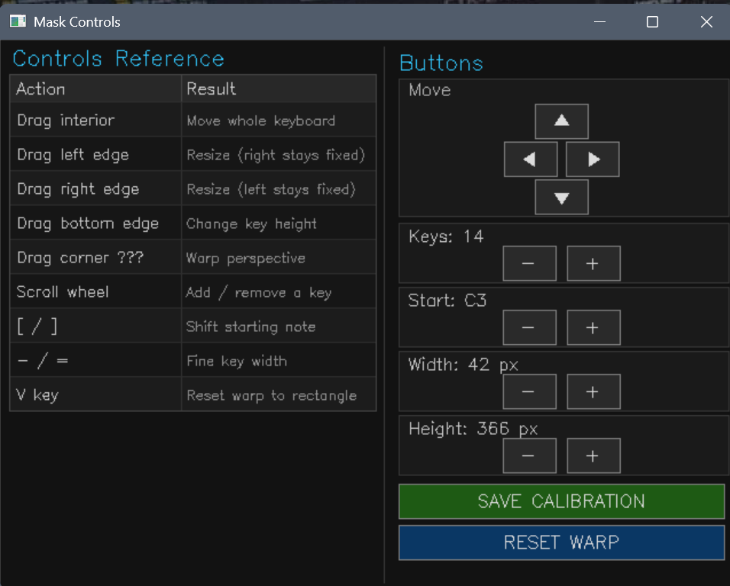
Fig: Polygon containment mask controls

6.3.3 Perspective Homography Calibration
Additionally, due to the tripod placement rarely producing a perfect straight view of the mask to perfectly sync with the live preview and the offline calculation, a perspective homography transformation matrix calibration, which warps the mask to a quadrilateral fitting the corners with corner drag controls, was developed following the approach outlined in Siddique et al. (2019). The cv2.getPrespectiveTransform computed the homography matrix. The transformation is defined as:
$${\tilde{p}}^{'}=H\tilde{p} , H∈R^{3×3}$$
Where: $\tilde{p}=[x,y,1]^{⊤}$are homogeneous coordinates
The warped vertex computation:
$v_{i}^{'​}​=π\left(Hv\sim i​\right)$

The warped polygon vertices are recovered via dehomogenisation:
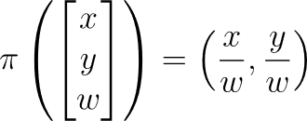

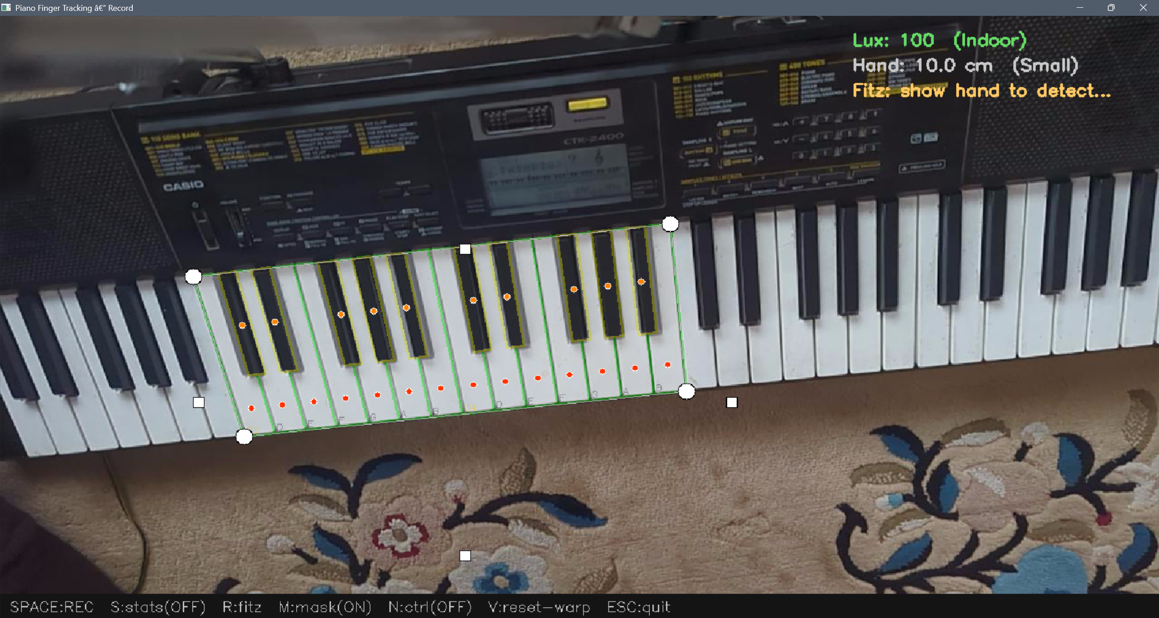
Fig: homography calibration mask

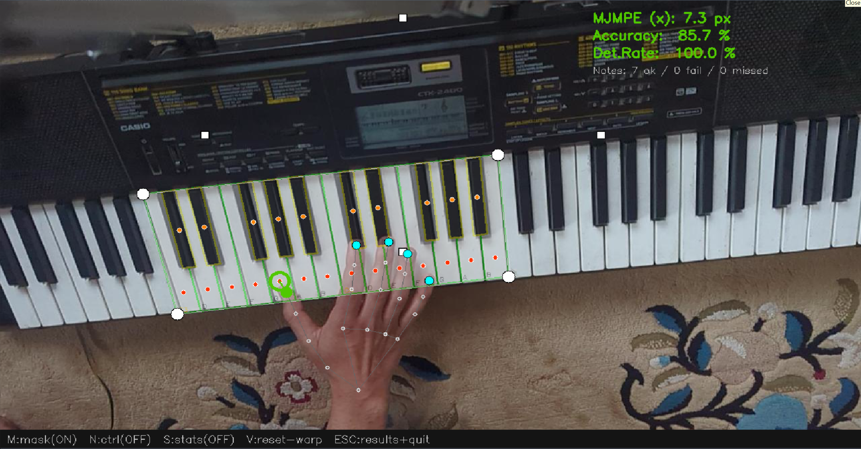Fig: correct landmark detection
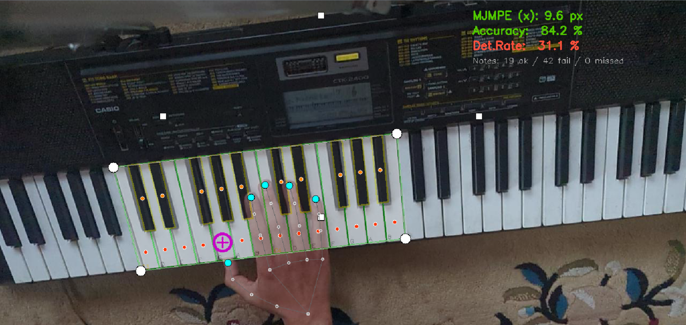
Fig: out of polygon mask false detection

6.4 Synchronized Multi-modal Data Acquisition
For accurate MJMPE calculations MIDI note events and video frames require sub frame temporal precision. By utilizing a shared time origin anchor by time.pref_counter() call when the recording starts, the frame and MIDI timestamps are also recorded independently.

6.4.1 MIDI–Video Temporal Alignment
MIDI recorder runs as a background daemon thread. Every 1ms, using mido’s iter_pending() interface MIDI input port is surveyed. Timestamped messages have shared origin (rec_t0). The frame logger simultaneously records (frame_index, time_s) for every frame written to disk. Two aligned time series as saved in csv and JSON files with the same origin expressed in seconds. By using a linear search on the log, the nearest note event to the video frame is retrieved. This ensures each note corresponds to the closest captured frame.

6.5 System Performance and Detection Statistics
Frames per second (FPS), MediaPipe inference latency (ms), and frame processing latency (ms) are some metrics calculated in real time to monitor performance. To identify any performance degradation, these metrics are displayed live during recording.
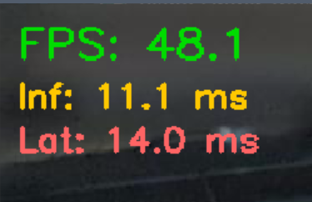
Fig: live_preview statistics
For each session, detected statistics for every MIDI note_on event are categorized into one of three outcomes: matched (correct landmark detection inside key polygon, detection fail (no fingertip landed within the key boundary when hand landmarks were present), or missed (no hand landmarks were detected). From the outcomes, these metrics were obtained:
The Mean Joint Model Positional Error (MJMPE):
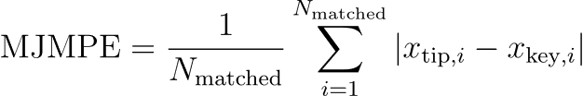
the Detection Rate (DR):
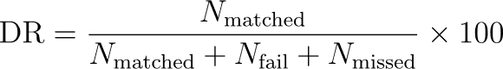

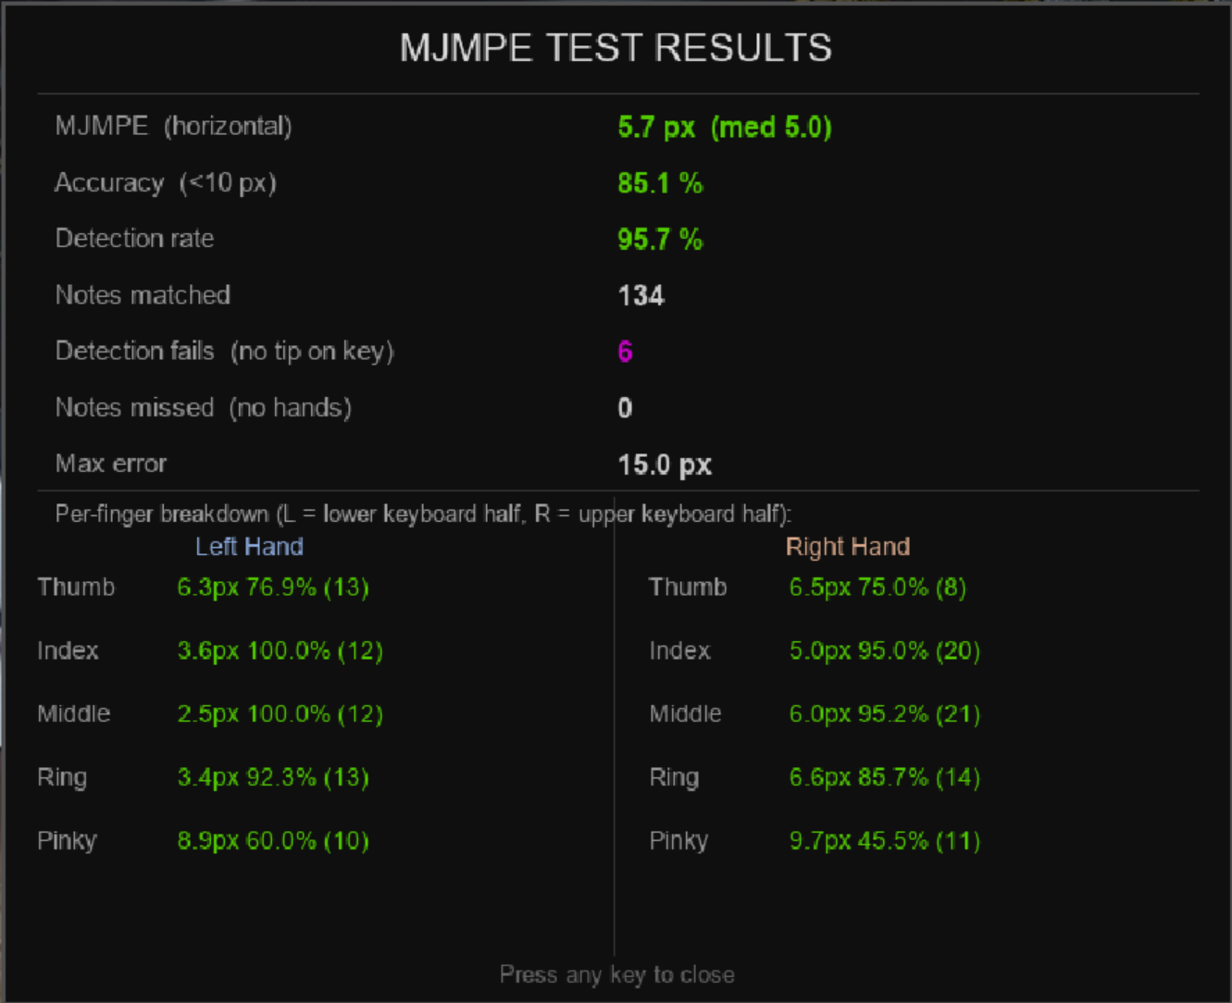
Fig: live_preview.py per hand per finger result

6.6 Participant Study Design
A study with three pre-planned patterns was completed by each participant using the same hardware configuration to evaluate tracking performance among participant demographics and illuminance conditions.

6.6.1 Participant Recruitment and Inclusion Criteria
Participants' recruitment was done through recommendations and signing consent forms. No exclusion criteria were applied based on skin tone or hand size. For relevant tracking performance diversity across Fitzpatrick phototypes and hand sizes was actively sought. A total of {N} participants participated in this study.

6.6.2 Session Protocol and Procedure
Each participant completed a predefined pattern session. After manually entering the lux value, hand size, and identifying participants, the following three patterns were played.
- Five-Finger Position: C-D-E-F-G pattern for both hands with no finger crossing, ascending and descending 4 times.
- One-Octave C Major Scale: C to C on the octave with one finger cross.
- Black Key Pentatonic Scale: C#-D#-E#-F#-G# on the black keys ascending and descending 4 times

6.6.3 Dataset Structure and Storage
All raw data from each session was written to a dedicated folder at data/raw/p###/. Each participant folder has frames.csv containing all the frame data with the timestamps, the details of the session with participants' variables and illuminance data, and midi data in JSON and a mid-file with frame and timestamps synchronized.
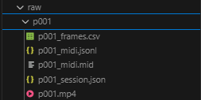
Fig: Raw data saved structure

6.7 Offline MJMPE Analysis
After the data collection process, the midi data and frame data were processed by both MediaPipe Hands and OpenPose independently. The resulting MJMPE, detection rate, and per-hand with per finger breakdowns are stored in the processed folder individually, meaning each participant will have their own result file, p#_mediapipe_results.json and p#_openpose_results.json.

7 Results
Over 25 participants played the piano under the setup, totaling up to 40 videos. Some of the participants played twice under different lighting conditions dim (<100 lux) and indoors (>100 lux). The resulting data had x number of rows from 3.30+ GB of video data.

7.1 Overall Model Performance

7.1.1 MJMPE

7.1.2 Detection Rate
As mentioned from the previous formula in section 6.3.1
— MJMPE and Detection Rate: MediaPipe vs OpenPose side-by-side table
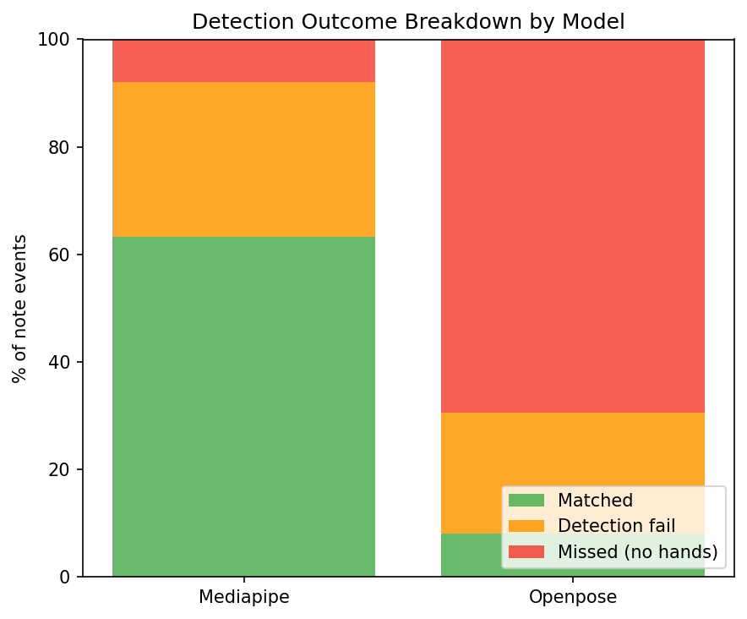
Fig: MediaPipe vs OpenPose detection rate chart
7.1.3 Detection Outcome Breakdown

7.2 Per-Hand Accuracy and Per-Finger Accuracy

7.2.1 Hand Assignment and Per-Finger Computation
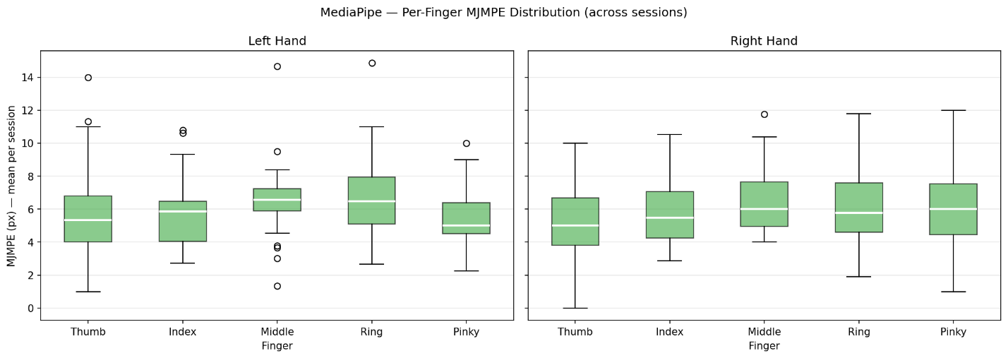
Fig: Per hand and finger breakdown for MJMPE

7.2.2 Per-Hand Match Rate

7.2.3 Camera Perspective as the Cause

7.2.4 2D Mask Perspective Note
A problem encountered during the mask calibration is accounting for 3d shape of the keys when the camera is angled overhead. Further the key is from the camera the more 3D error is introduced with the calibration mask, so most pieces played were positioned near C5 and some notes rarely at C6. Notes near C6 have introduced minor bias and may contribute to detection miss even if notes were pressed inside the polygon containment box.
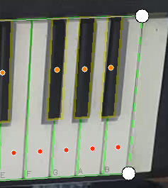
Fig: 3D error on black keys from 2D calibration mask misalignment

7.2.5 MediaPipe Per-Finger MJMPE

7.2.6 OpenPose Per-Finger MJMPE

7.2.7 Per-Finger Distribution Across Sessions
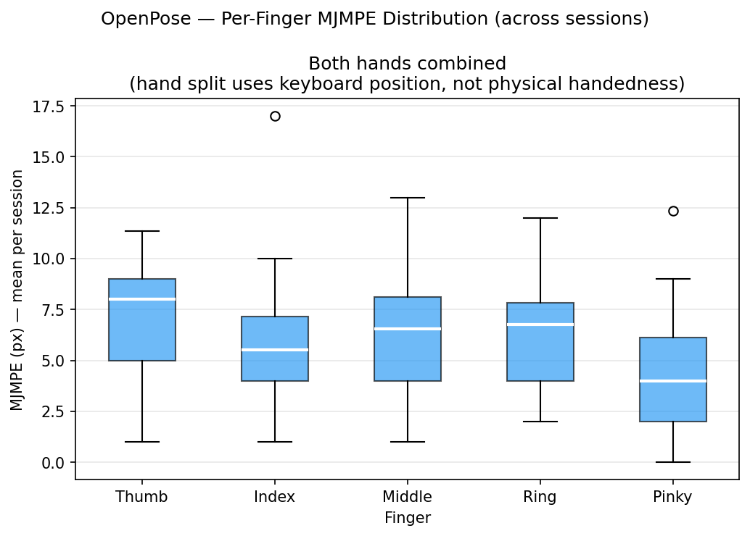
Fig: Overall MJMPE combined for both hands OpenPose
— Highlight which fingers each model struggles with

7.3 Effect of Skin Tone (Fitzpatrick Type)

7.3.1 Computation

7.3.2 MJMPE by Fitzpatrick Type
7.3.3 Detection-Fail Rate by Fitzpatrick Type 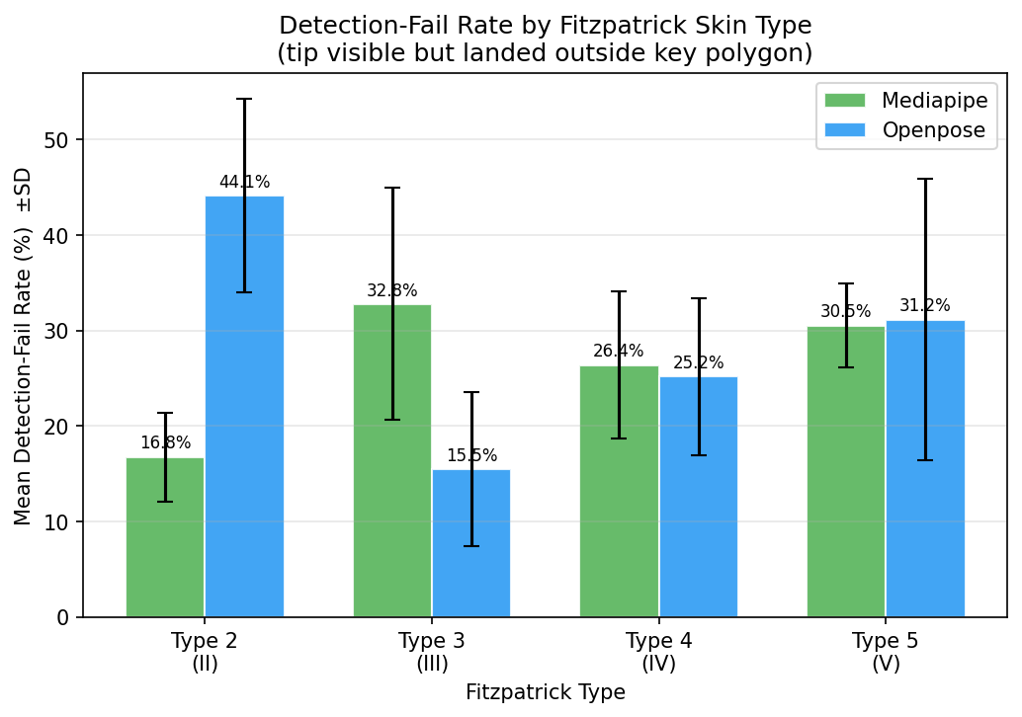
Fig: detection fail rate by skin tone

7.4 Effect of Ambient Illuminance

7.4.1 Computation

7.4.2 MJMPE by Lighting Condition
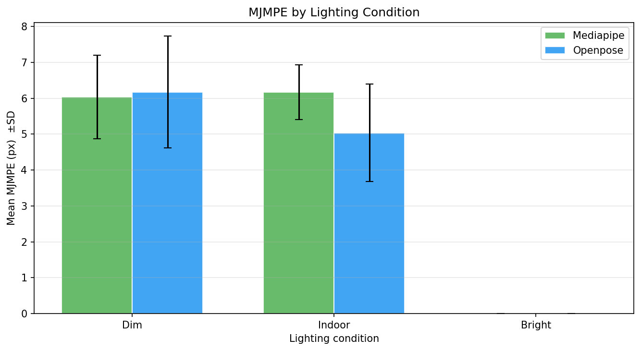
Fig: Mean MJMPE per lighting category

7.4.3 Detection-Fail Rate by Lighting Condition 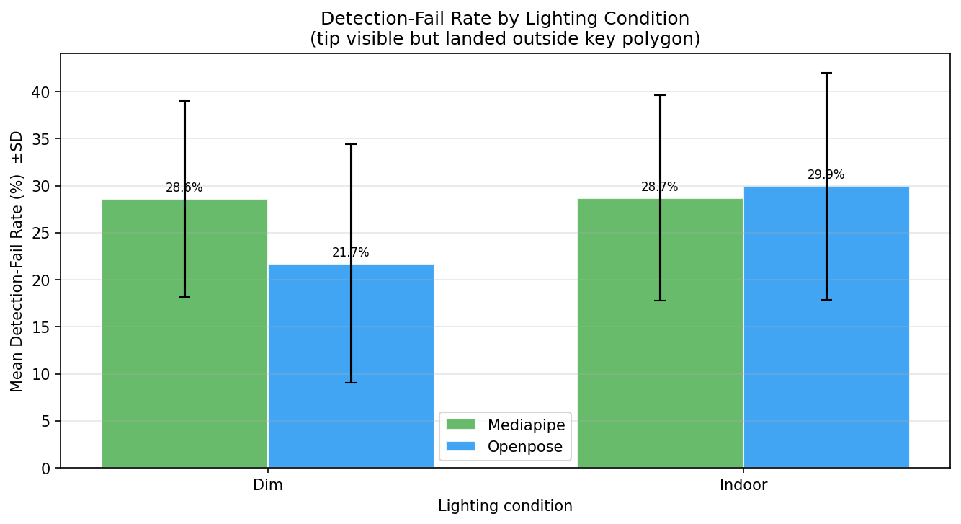
Fig: detection fail rate by lighting condition

7.5 Effect of Hand Size

7.5.1 Computation

7.5.2 MJMPE vs Hand Size 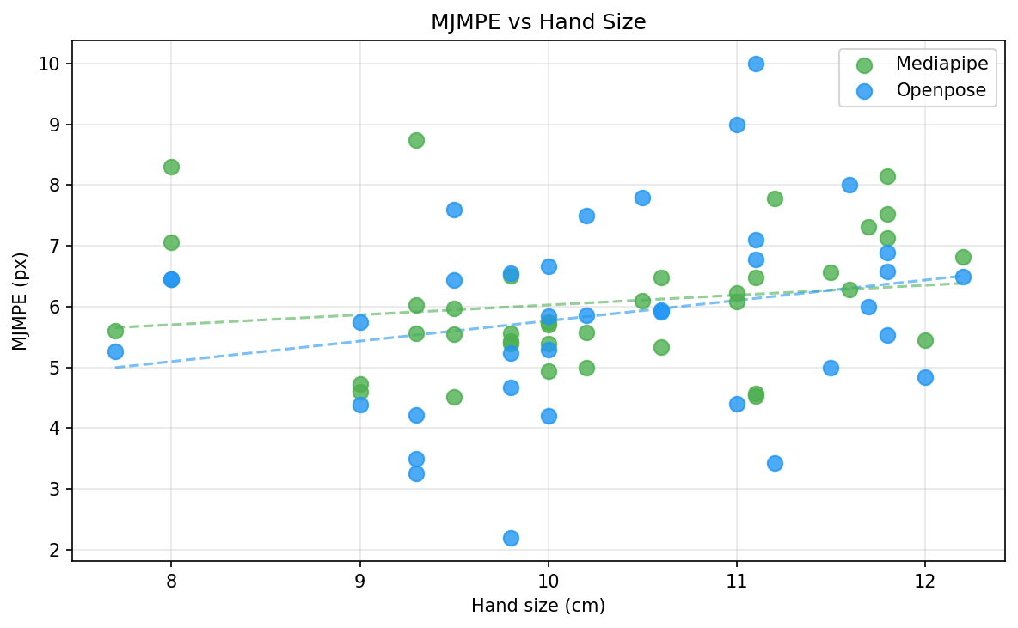
Fig: Hand size and MJMPE correlation chart

Conclusion

8.1 Summary of Project Aim and Outcomes

8.2 Novel Contributions

8.3 Room for Future Development

Installation guideline
Python 3.10+ is required for this system; installation can be done from the Microsoft Store or python website. The requirements.txt includes all the required frameworks and libraries. A Python virtual environment should be used to fix any dependency issues, as many libraries aren’t supported on the latest version. The command python -m venv <environment name> without the <> can be used to initialize via terminal. After activating the script using venv\Scripts\activate, the requirements.txt has all the required sources; the command pip install -r requirements.txt can be used to install all Python dependencies via terminal. The full guide will be included in the Installation Guidelines file.

Bibliography
- Buolamwini, J. and Gebru, T. (2018) 'Gender Shades: Intersectional Accuracy Disparities in Commercial Gender Classification', Proceedings of Machine Learning Research, 81, pp. 1–15.
- Cao, Z., Hidalgo, G., Simon, T., Wei, S.E. and Sheikh, Y. (2019) 'OpenPose: Realtime Multi-Person 2D Pose Estimation using Part Affinity Fields', IEEE Transactions on Pattern Analysis and Machine Intelligence, 43(1), pp. 172–186.
- Chardon, J.L., Cretois, I. and Hourseau, C. (1991) 'Skin colour typology and suntanning pathways', International Journal of Cosmetic Science, 13(4), pp. 191–208.
- Cho, S., Bala, R., Bhatt, U., Mattina, M., Fenstermacher, P. and Moorosi, N. (2023) 'Consensus and Subjectivity of Skin Tone Annotation for ML Fairness', Advances in Neural Information Processing Systems (NeurIPS).
- Chung, J.-L., Ong, L.-Y. and Leow, M.-C. (2022) 'Comparative Analysis of Skeleton-Based Human Pose Estimation', Future Internet, 14(12), article 380. doi: 10.3390/fi14120380.
- Fitzpatrick, T.B. (1988) 'The Validity and Practicality of Sun-Reactive Skin Types I Through VI', Archives of Dermatology, 124(6), pp. 869–871.
- Han, J., Shao, L., Xu, D. and Shotton, J. (2013) 'Enhanced Computer Vision with Microsoft Kinect Sensor: A Review', IEEE Transactions on Cybernetics, 43(5), pp. 1318–1334. doi: 10.1109/TCYB.2013.2265378.
- Hiranaka, A., Grown-Haeberli, E. and Xue, K. (2022) AR Piano Playing Using Real-Time Hand Tracking. Stanford University Course Report. Available at: https://misoshiruseijin.github.io/documents/ar_piano.pdf (Accessed: 6 March 2026).
- Hürst, W. and Van Wezel, C. (2013) 'Gesture-based interaction via finger tracking for mobile augmented reality', Multimedia Tools and Applications, 62(1), pp. 233–258. doi: 10.1007/s11042-011-0983-y.
- Jo, B. and Kim, S. (2022) 'Comparative Analysis of OpenPose, PoseNet, and MoveNet Models for Pose Estimation in Mobile Devices', Traitement du Signal, 39(1), pp. 119–124. doi: 10.18280/ts.390111.
- Lee, S., Rim, J., Jeong, B., Kim, G., Woo, B., Lee, H., Cho, S. and Kwak, S. (2023) 'Human Pose Estimation in Extremely Low-Light Conditions', in Proceedings of the IEEE/CVF Conference on Computer Vision and Pattern Recognition (CVPR), June 2023, pp. 704–714. Available at: https://arxiv.org/abs/2303.15410
- Liang, H., Wang, J., Sun, Q., Liu, Y., Yuan, J., Luo, J. and He, Y. (2016) 'Barehanded Music: Real-Time Hand Interaction for Virtual Piano', in Proceedings of the 20th ACM SIGGRAPH Symposium on Interactive 3D Graphics and Games (I3D '16), New York: ACM, pp. 87–94. doi: 10.1145/2856400.2856411.
- Lugaresi, C., Tang, J., Nash, H., McClanahan, C., Uboweja, E., Hays, M., Zhang, F., Chang, C.L., Yong, M.G., Lee, J., Chang, W.T., Hua, W., Georg, M. and Grundmann, M. (2019) MediaPipe: A Framework for Building Perception Pipelines. arXiv:1906.08172. Available at: https://arxiv.org/abs/1906.08172
- Martin, J. (1991) Rapid Application Development. New York: Macmillan.
- Mehrabi, N., Morstatter, F., Saxena, N., Lerman, K. and Galstyan, A. (2021) 'A Survey on Bias and Fairness in Machine Learning', ACM Computing Surveys, 54(6), pp. 1–35. doi: 10.1145/3457607.
- Molchanov, P., Yang, X., Gupta, S., Kim, K., Tyree, S. and Kautz, J. (2016) 'Online Detection and Classification of Dynamic Hand Gestures with Recurrent 3D Convolutional Neural Networks', in Proceedings of the IEEE Conference on Computer Vision and Pattern Recognition (CVPR), pp. 4207–4215.
- Mueller, F., Bernard, F., Sotnychenko, O., Mehta, D., Sridhar, S., Casas, D. and Theobalt, C. (2018) 'GANerated Hands for Real-Time 3D Hand Tracking from Monocular RGB', in Proceedings of the IEEE Conference on Computer Vision and Pattern Recognition (CVPR), pp. 49–59.
- Pu, M., Chong, C.Y. and Lim, M.K. (2023) Robustness Evaluation in Hand Pose Estimation Models using Metamorphic Testing. arXiv:2303.04566. Available at: https://arxiv.org/abs/2303.04566
- Salz, D. and Azam, F. (2019) Playing a Virtual Piano with Dynamics. Stanford University EE267 Course Report.
- Siddique, A., Bhatt, U. and Xu, W. (2019) 'Images Alignment Using Homography Transformation Matrix', ResearchGate. Available at: https://www.researchgate.net/publication/334107601
- Zhang, F., Bazarevsky, V., Vakunov, A., Tkachenka, A., Sung, G., Chang, C.L. and Grundmann, M. (2020) MediaPipe Hands: On-device Real-time Hand Tracking. arXiv:2006.10214. Available at: https://arxiv.org/abs/2006.10214

Appendices

